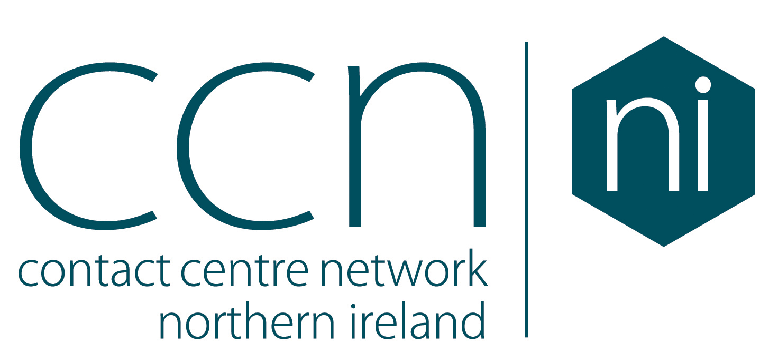

Contact Centre Membership 2021

E-mail:

E-mail:

E-mail:

E-mail:

E-mail:

E-mail:

**Additional names to receive e-mail updates**

Name

Name

Name

Head of HR

Head of IT

Head of Training

E-mail:

On site:

Head of Contact Centre

No. of employees   
in Contact Centre:

**Nature of the Business:**

**Sector**

E-mail

Tel:

Postcode:

Signature:

Head Office Address:

Address:

Company name:

Job Title:

Name:



**Return:** On completion please email this form to [**info@ccnni.com**](mailto:info@ccnni.com)Contact Centre Network NI Ltd, The Maltings, East Tyndall Street, Cardiff CF24 5EA. Company No: 11260851

Name

Date

***I agree to the above Terms & Conditions of Membership (tick as required)***

**Terms & Conditions:**Annual membership of CCNNI is for a period of 12 months. CCNNI will raise an invoice to reflect the Membership selected. Membership will be activated upon the receipt of payment of the appropriate invoice within 30 days of the invoice date. Before the end of your Membership Period, details of renewed Membership will be discussed with you and agreed within at least one month prior to the expiry date of your current Membership to ensure continuity and enable the appropriate invoice and renewal to be processed.  **Cancellation:**If you wish to cancel your new membership, you may do so by informing us of your intention up to 10 working days before the start of the Membership Period. This notice should be provided directly to us, in writing by email to [info@ccnni.com](mailto:info@ccnni.com). For existing members, Membership Renewal may be terminated in writing with no less than one month's notice. All Membership fees are non-refundable.

Micro – Organisations with 1-29 seats – **£4,120** +VAT per annum  
 SME – Organisations with 30-249 seats – **£4,370** +VAT per annum   
 Large – Organisations with over 250 seats – **£4,620** +VAT per annum

***Please invoice me for the following amount: (tick as appropriate)***

**3: PLATINUM MEMBERSHIP**

Unlimited Helpdesk & Linkedin Group, Topical User Groups, Benchmarking & Best Practice Events, Industry Research, Free entry to the Annual Awards, 10% discounted rates on CCNNI commercial activities,   
1 VIP Table at the Annual Awards, Sponsorship of 1 Awards category or Industry Workshop / Presentation

***Please invoice me for the following amount: (tick as appropriate)***

**2: ENHANCED MEMBERSHIP**

Unlimited Helpdesk & Linkedin Group, Topical User Groups, Benchmarking & Best Practice Events Industry Research, Free entry to the Annual Awards, 10% discounted rates on CCNNI commercial activities, 1 Premier Table at the Annual Awards.

Micro – Organisations with 1-29 seats – **£1,940** +VAT per annum  
 SME – Organisations with 30-249 seats – **£2,190** +VAT per annum   
 Large – Organisations with over 250 seats – **£2,440** +VAT per annum

Micro – Organisations with 1-29 seats – **£500** +VAT per annum  
 SME – Organisations with 30-249 seats – **£750** +VAT per annum   
 Large – Organisations with over 250 seats – **£1000** +VAT per annum

***Please invoice me for the following amount: (tick as appropriate)***

**2021 Membership Packages**

**1: STANDARD MEMBERSHIP**

Unlimited Helpdesk & Linkedin Group, Topical User Groups, Benchmarking & Best Practice Events Industry Research, Free entry to the Annual Awards, 10% discounted rates on CCNNI commercial activities